## Notes on constructing the state and local portions of the FIM

State and local purchases and tax revenue are closely related. While the causality more likely runs from tax revenues to purchases more than vice versa, we’re interested in using readily available forecasts of state and local expenditures (from CBO) to forecast underlying state and local tax revenues.

The figures below use historical data from 1970Q1 through 2018Q4. The right column plots growth rates in purchases against revenues, and the left plots log-levels against log-levels. The bottom row adds federal grants to tax revenues on the y-axis. The figures indicate that purchases move closely with tax revenues and even more closely with total revenues including grants.

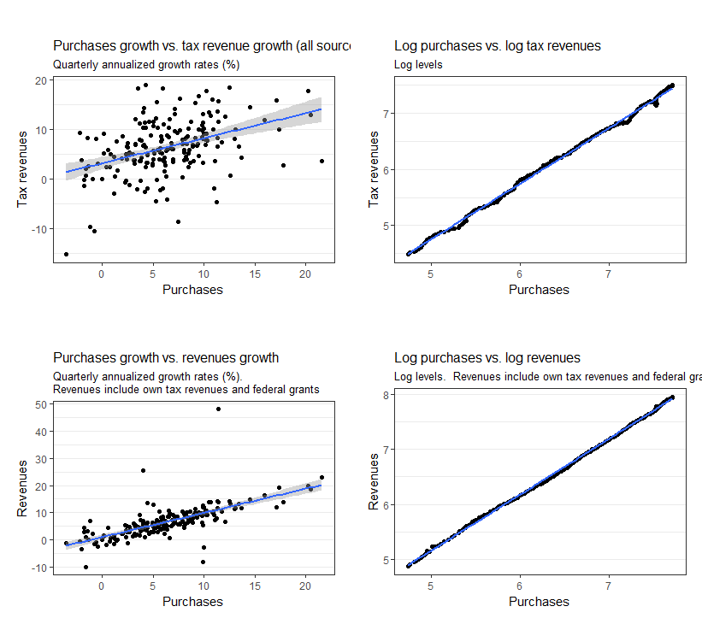

Another way of looking at this is to ask, if we only had information on the growth rate of purchases, how well could we have predicted tax revenues in the 50 years? Below we construct predicted tax revenues for 2016Q1 through 2018Q4 *dynamically—*that is, where each predicted value of tax revenues equals

$${(1+g}_{t}^{purchases}){\hat{τ}}_{t-1}$$

Where $g_{t}^{purchases}$ is the observed growth rate of purchases in t and ${\hat{τ}}_{t-1}$ is the lagged *predicted* value of taxes. This is how we would ostensibly forecast tax revenues for the FIM.

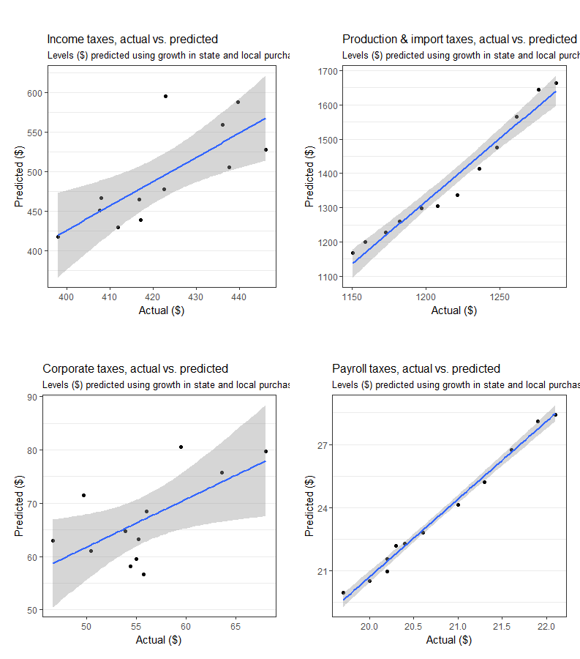

Interestingly, the two

While total tax revenues are linked to total purchases, the relationship varies depending on the revenue source.

From NASBO fall 2018 fiscal survey of the states:

States enacted appropriation increases for fiscal 2019 totaling $41.1 billion across all program areas, compared to just $12.7 billion in new appropriations enacted in their fiscal 2018 budgets one year prior.

“States enacted a mix of tax and fee increases and decreases during the 2018 legislative session, resulting in a projected net positive revenue impact in fiscal 2019 of $3.1 billion, including $2.7 billion in additional general fund revenues. Overall, 16 states approved net tax and fee increases totaling $4.6 billion in fiscal 2019, while 20 states enacted smaller net decreases totaling -$1.4 billion” (54).

<https://www.urban.org/research/publication/state-revenues-grew-third-quarter-income-taxes-face-uncertain-prospects>